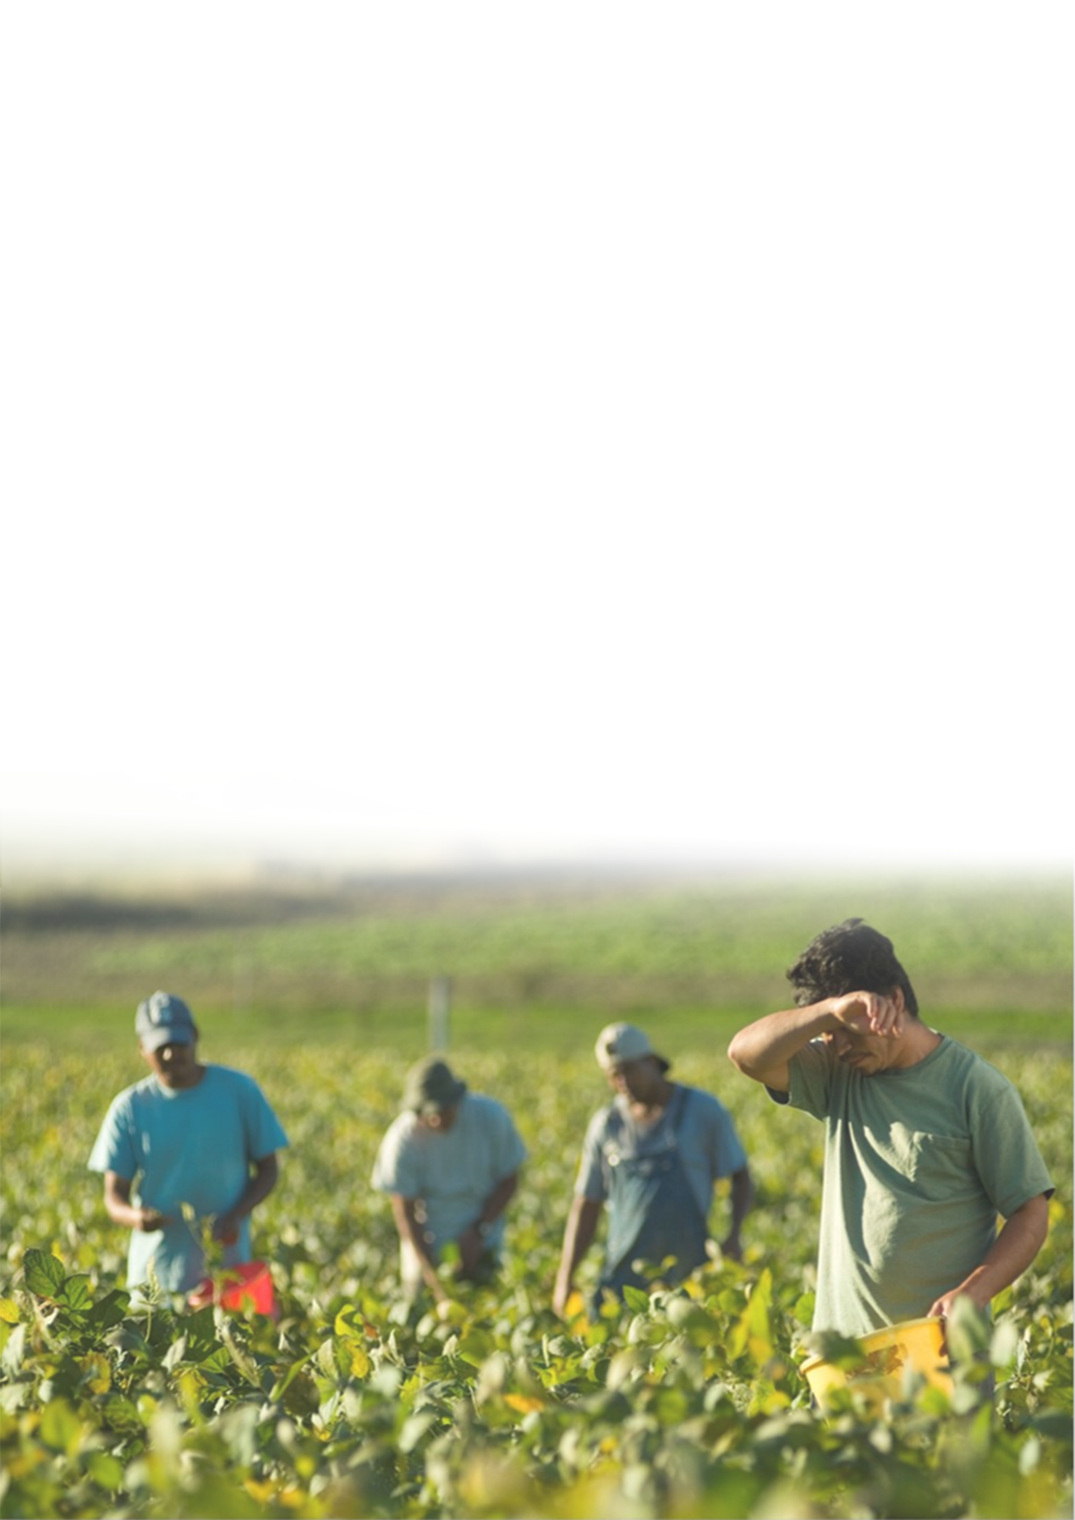

Agricultural Worker
Heat Stress Training

Facilitator Guide

Table of Contents
Quick Start 3

Part 1 Curriculum Overview 7
Description 7
Instructional Goal 7
Target Learners 7
Delivery Method 7
Learning Objectives 8
Materials 8
Part 2 Instruction 9
Appendix 32
Florida Worker's Compensation Law 32
Georgia Worker's Compensation Law 35
References 38

Quick Start
Before the Training
- Know the audience
- This training is intended for migrant and immigrant farmworkers living and working in the South Eastern United States. This population is mostly from Mexico and Central America. They speak primarily Spanish and have limited formal education. Some may not be able to read and write. Try to gather as much information about the audience as you can before you train them. If possible find out about their needs and past experiences with the content.
- Consider the cultural background of the trainees. Make sure relevant points are addressed in a culturally appropriately way. There are several places in the training where cultural beliefs and practices are included. For example, some Latino farmworkers believe that using water to wash their hands and bathe when they are hot might make them sick. It is important to acknowledge this belief and to point out why it’s so important to wash hands and bathe after working with pesticides.
- Sometimes talking about pesticides can be very scary because we are talking about something that affects the health of the participants and their family members. It is important to reassure participants that the purpose of the training is not to scare them, but to help them understand how they prevent being exposed.
- Tips for teaching adult learners
- Keep the number of participants per training to 12 or 15 individuals if possible so that you can make it as participatory as possible.
- Make sure adult learners understand WHY this training is important and HOW it is relevant to their lives.
- Try to engage everyone while respecting their own learning styles.
- Encourage learners to ask questions.
- Review the facilitator guide
Refresh your knowledge before you facilitate a training and practice facilitating the training if it’s your first time using this training.
- Prepare materials
Prepare materials for training activities; Print out handout and pre and post assessments.-.
- Set up the room
The best set up is a semi-circle of chairs, without any desks or tables.
If you are using the Power Point presentation, try to have the projector behind you so that it doesn’t stand between you and the participants. If you are using a flipchart, just have it next to you.
- Keep track of time
Use a watch to keep track of time. Adjust the training as needed to ensure you cover the material.
- Distribute assessment materials
If using a pre and post assessment, provide each participant a pre-assessment. It is important to explain to participants that these are to help you, the facilitator, know how you are doing with the training. It is a good idea to read each question aloud. Walk around the room as you are reading the questions. Help anyone that may not be able to read so they can answer the questions.

During the Training
- Keep the facilitator guide for reference
Use the facilitator guide to keep track of the material and activities. Avoid reading the content word for word. Showing confidence about the content will make learners feel confident to learn.
- Keep track of the time
Adjust the class activities if time allows.
- Use your “Presentation Persona”
Voice: Vary the tone of your voice.
Body: Use hand gestures, make eye contact, move around and towards
participants.
- Customize for different audiences
The training can be tailored to the learners’ needs and experiences. It can be customized by altering the time spent and emphasis on each section, on examples, and on activities.
- Encourage participant engagement
Training is more effective when the leaners take an active part. A series of guided questions are included in this training. Be sure to ask these questions and give enough time for the participants to answer. Always give positive feedback after these activities as this will encourage active learning throughout the training.

After the Training
- Collect assessment materials and feedback from participants
Getting direct feedback from participants will help you improve the training for future use.
- Answer any individual questions after the workshop if time allows
Allow participants to ask further questions, resulting in retention of the knowledge. It also gives shy learners a chance to ask questions and share what they learned.
- Sincerely thank the participants for attending the training session.

Part 1: Curriculum Overview
Description
. The curriculum aims to improve farmworkers’ knowledge and foster changes in attitude regarding heat stress. The goal is to change behavior that will help farmworkers protect themselves and their families from heat stress illnesses.

Instructional Goal
The goal of the training is to educate farmworkers in order to increase knowledge about heat stress and appropriate actions to take in order to protect themselves and their families.

Target Learners
Learners are Latino farmworkers in Florida and South Georgia. They have
relevant low literacy levels.

Delivery Method
This training is designed to be facilitated in-person with either a flip chart
or Power Point presentation.

Number of Participants
To facilitate active learner engagement, the ideal number of participants is 12-15.

Time
60 minutes

Instructional objectives
After the training, the farmworkers will be able to:
- identify the symptoms of heat stress exposure.
- take appropriate actions to prevent potential heat stress exposure.
- apply the proper procedures if experiencing heat illnesses.

Materials

The following materials are needed during the training session:
- PowerPoint Presentation or Flipchart Presentation
- Blank Flipchart Sheets
- Facilitator guide
- Video clips

*Notes to facilitator
In the presentation slides, you will see many brainstorming question slides like below. Be sure to ask these questions and give enough time for the participants to answer. Always give positive feedback after these activities.
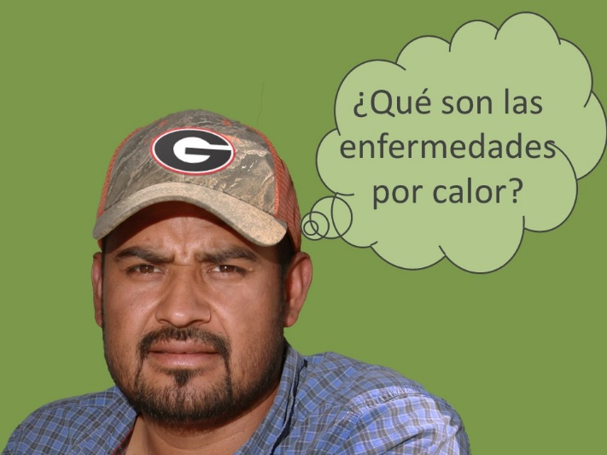
Part 2: Instruction
Slides | Notes
Slide 1 | - Introduce yourself and the presentation briefly.  Trainer: The PISCA program is supported by the National Institute for Occupational Safety and Health through a grant to the Southeastern Coastal Center for Agricultural Health and Safety. Our primary goal in this project is to help you prevent heat illness. We hope will leave our time together knowing that heat illness, which can be life threatening, is completely preventable. Your experiences and participation will be part of our talk about how you can prevent heat illness, and what you should do if you or someone else experiences heat illness. Let’s get started with a short video…
Slide 2  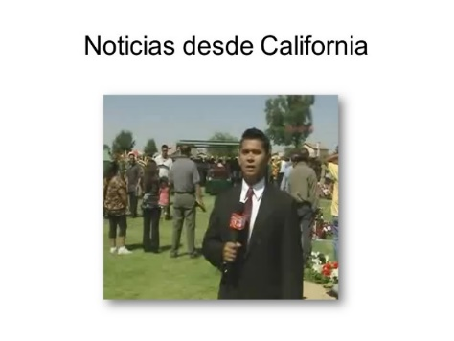 | - Play the video.  - Summarize the main content of the video  - Ask participants if they had experience with heat illness.  - Wait for participants to answer. Ask more questions to clarify and try to connect it to training if needed.  Trainer: AT THE END OF THE VIDEO- This video shows an extreme case of diseases related to heat - someone died. In Florida, in 2015, there were at least two cases of workers who died while they were harvesting. But heat-related illnesses do not always end in death, another serious case is a permanent disability, and probably many of us have already suffered from diseases, or at least we have been close to having them. For example, many experts agree that the feeling of being thirsty is the first symptom of a heat-related illness.
Slide 3
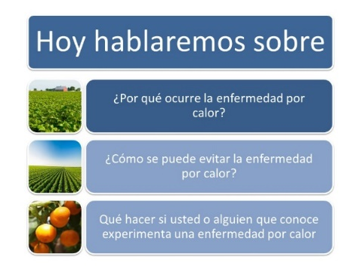
Slide 4  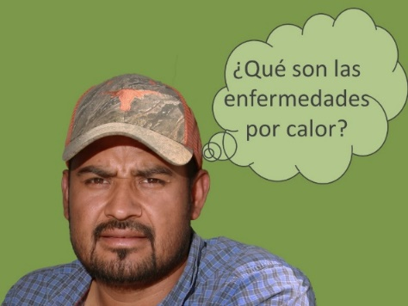 | *Notes: Every brainstorming question slide means you should stop and interact with participants on these questions.  - Ask the question on the slide. Allow participants to answer the question.
Slide 5  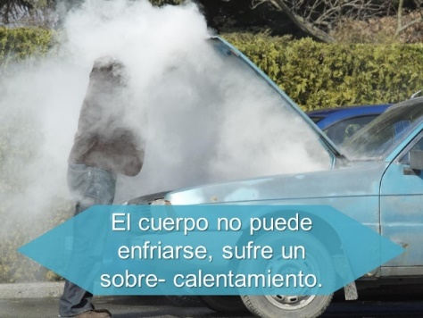 | - Take responses from participants. Then make the comparison with the car cooling system.  Trainer: This illustration gives a good picture of heat illness. When a car does not have enough water or oil, or when it is forced to its limits, the car will overheat. The same thing can happen to our body. Just like this car, our body can overheat if we do not have enough water, electrolytes, and we work beyond our capacity. When we are thirsty -- our body is asking for water – our body already knows that we do not have enough water to cool itself down.  - Ask participants if the car gives the driver any warning signs of its condition? Allow participants to answer the question.  - Make the connection between warning signs from the car and our bodies.  Trainer: If the car had a monitor, like a light in the panel when the car is overheated, the owner may had taken some precautions like adding water. Our body also sends signs when our body is getting too much heat. Recognizing and responding to these signs is what makes health related illness preventable. People should not be dying from heat, or even getting in to the hospital because of heat. Heat-related illness are preventable. If you recognize the illness you can change its effects, decrease its risk, and even be more productive.
Slide 6  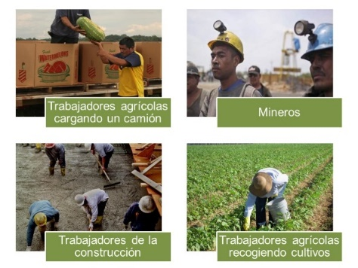 | - Ask participants what occupations are more affected by heat. Allow participants to answer the question.  - Show the occupations that are more likely to be affected by heat.  Trainer: Workers from a variety of occupations – especially manual labor jobs that occur outdoors, like mining, fishing, construction, and farmworkers.  But it can also affect indoors workers in hot environments like packing houses, kitchen and bakery workers, and factory workers.
Slides 7  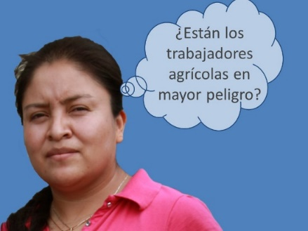 | - Ask the question on the slide. Allow participants to answer the question.
Slide 8  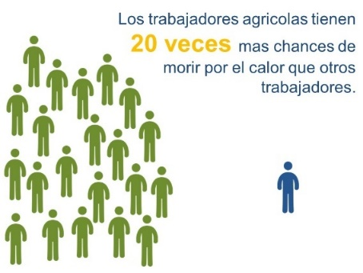 | - Share the data on the impact of heat illnesses for farmworkers.  Trainer: If you thought that farmworkers are at higher risk for heat related illness, you were right. The U.S. Center of Disease Control found that death rate for heat illnesses is 20-times greater in farmworkers than in the general population.  And when the CDC mentions farmworkers they are referring to workers in any crop, and any part of the operation, which mean from packing workers, to bus drivers, to supervisors, crew leaders, and growers. The workers in the field – those who are planting, weeding or harvesting are most at risk.
Slides 9  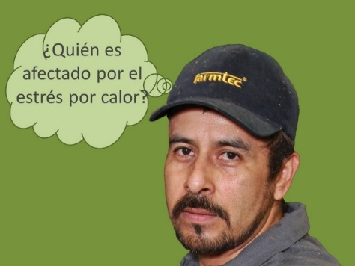 | - Ask the question on the slide. Allow participants to answer the question.
Slide 10  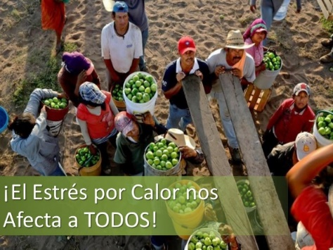 | - Point out that every worker is affected even if they are young and healthy.  Trainer: Everybody is affected, men and women, young and old, Mexican, American, Salvadorian, Guatemalan, Canadian…. Especially workers in hot and humid conditions like we have here in southern GA/northern FL is at risk of heat illness, even if you are young and healthy.
Slide 11  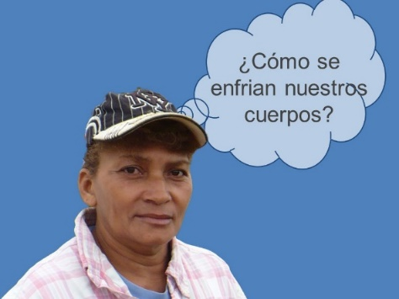 | - Ask the question on the slide. Allow participants to answer the question.
Slide 12  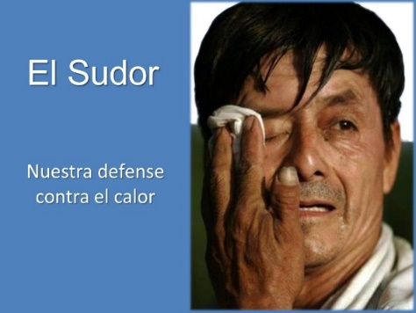 | - Ask participants how our bodies are responding against heat stress. Wait for participants to respond.  - Explain sweating by stressing the following points  - Sweat cools your body down when it evaporates.  - The more you sweat, the more water you are losing from your body.  - Our blood circulation also cools us down, but it is not the main way.  Trainer: Sweating itself does not cool your body – it can‘t because the sweat comes from inside your body; therefore it is the same temperature as your body. Sweat cools your body down when it evaporates. When the droplets of sweat evaporate or dry, it lowers your body’s temperature. This is why heavy clothes or wearing protective equipment can cause your body to overheat --- because they don’t let your sweat evaporate.  Sweat is mainly water – along with electrolytes – so the more you sweat, the more water you are losing from your body.  Our blood circulation also cools us down. Even though circulation is not the main way of cooling the body down, the blood system will do a better job if we have enough water in our bodies.
Slide 13  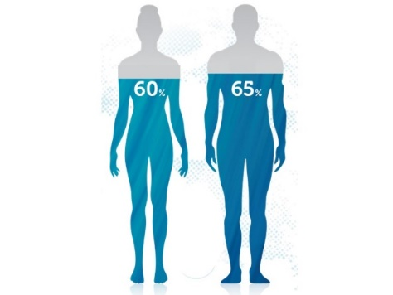 | - Use the previous cases and experiences mentioned by participants to discuss the amount of water in human body  Trainer: Did you know the typical adult human body is 60% water, 20% fat, and 20% proteins and minerals? If we unbalance these percentages our body is going to start sounding an alarm. We are going to talk about what causes you to lose water, and some of the alarm signals that always occur before heat illness.
Slide 14  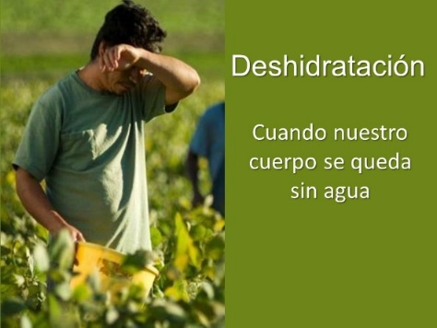 | - Let participants recall the car spewing smoke in the previous slide.  - Ask what happened and wait for their response.  - Make connections between the car and our body.  - If you sweat a lot and don’t replace that water, you will become dehydrated.  Trainer: Let us go back to the car example: what do you think it happen? It is most likely that the car ran out water, right? Perhaps the radiator had a leak, or the owner did not put water in to it for long, long time. Likewise, our body also needs water, our sweating is the leak (similar to an open faucet), and the harder we work the more water we lose.  Have you tasted your sweat? It is salty. The salty taste is from electrolytes; minerals that help our body function. We need them both to prevent heat related illness.  There are many ways to replace electrolytes, many of you drink sport drinks. Those drinks have electrolytes but also a lot of sugar, there are other products like coconut water or even lemon water with a bit of salt that have less sugar. Just remember: those drinks do not substitute drinking water.  Sweating is important for cooling your body down. If you sweat a lot and don’t replace that water, you will become dehydrated.
Slide 15  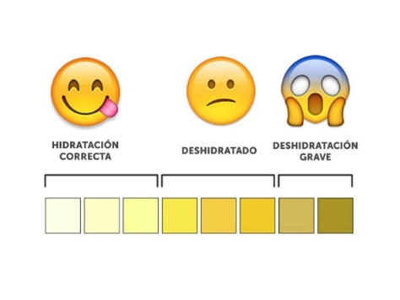 | - Point out that the color of urine shows the degree of dehydration  Trainer: A simple way to know how dehydrated this is by the color of your urine. If your urine is very dark it is because your body does not have enough water.
Slide16  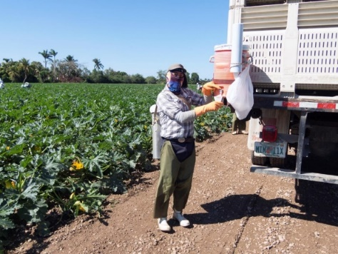 | - Point out that drinking water is the most important way of staying hydrated and preventing heat-related illness.  - Explain the regulations about providing water and bathroom on farms.  Trainer: According with the Occupational Safety and Health Administration (OSHA), the agency at the Department of Labor in charge of regulating and preventing workers injuries, workers should drink 1 cup (250mL) of water every 20 mins when working in the heat. We know this is unrealistic under the working conditions you are facing. However, we want you to have a strategy to have enough water in your body to stand the work you do. For instance, drinking a gallon of water before, during, and at the end of the day may be one strategy.  Although there are no regulations about working in the heat beside states of California and Washington, OSHA will investigate any heat related illness in which the workers ends up at the clinic or hospital. Workers, according with this agency, should have access to drinkable water, disposable cups, and time to access this water. However, they do not conduct inspections in farms, but when someone get sick they will investigate. If you get sick, your employer has to provide health care but may not cover for your incapacity.  Federal regulations, like the workers protection standard, or WPS, also require water in the field and bathrooms. Bathrooms, the regulations said, should be at reasonable distance and cleanness. They should have sanitary paper, and a place to wash your hands before and after going to the bathroom. We know that many farmworkers avoid going to do their needs for working reasons, but also because there are no bathrooms or they are nasty.  If you do not have access to water and bathrooms complain, you are in your right! Try to complain in group, so they listen to you.
Slide 17  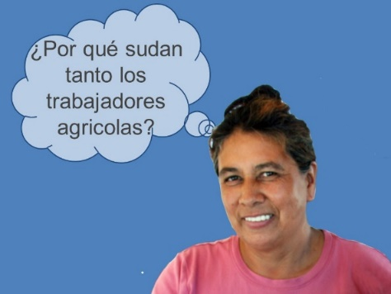 | - Ask the question on the slide. Allow participants to answer the question.
Slide 18  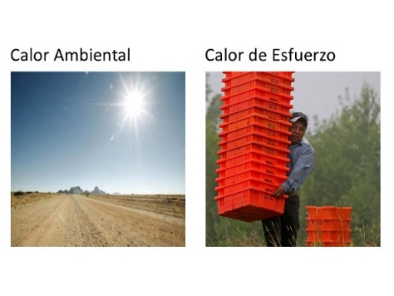 | - Categorize participants’ answers into environmental and exertional heat.  Trainer: All the ideas you shared can be put into two basic categories. Farmworkers sweat a lot because they are exposed to heat or conditions that make cooling down difficult, and because they work hard. Or, two forms of heat contribute to why farmworkers sweat so much: environmental heat, and the heat produced by our bodies to perform work or exertional heat.
Slide 19  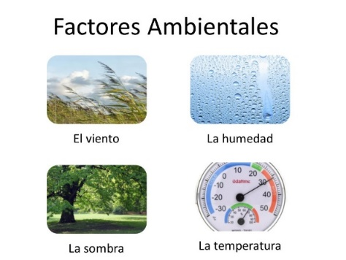 | - Ask participants the meaning of “environmental heat”. Allow participants to answer the question.  - Explain “environmental heat” through temperature, humidity, air movement.  Trainer: Environmental heat refers to several things. Today we are going to focus on three things that are all related to the weather.  First, there is temperature or the measure of how hot or cold it is. In most of the countries in the world temperature is measured in Celsius to mark the temperature, but in the United States temperature is measured in Fahrenheit. 50 degrees Fahrenheit is the 10 degrees Celsius; 68 degrees Fahrenheit is 20 degrees Celsius, and 86 degrees Fahrenheit is 30 degrees Celsius.  Although a thermometer will tell you the current temperature, the effects of the temperature of your body is greatly affected by other weather conditions like humidity. For instance, some of you may had heard a weather specialist saying the temperature is 85 degrees Fahrenheit, but it feels like 90. What does this mean?  Humidity is an important factor of heat. The more humid it is the more heat it creates in your surroundings. That is why it counts for the 5 degrees difference in the previous example.  Air movement is another factor that determines how much farmworkers sweat. You know, buildings used to have high ceilings, and in many of our countries our air conditionings are fans or open windows. These fans and open windows allow the air to move. The more the air moves the more refresh it feels because it helps your sweat evaporate more quickly. That is why working in some crops like corn fields with tall stalks or working in greenhouses feels hotter – there is less air movement.  Environmental heat refers to conditions that make it harder for your body to release heat…things like  - External temperatures  - High humidity  - Little wind/breeze  - Little shading  *Feel free to use the following example if time allows. （When I was a kid I went to the soccer games in Zacatepec, Mexico, it is a place under sea level. They always play at noon, and before the game they water the field. The players on that team train under the same circumstances every day, but the visiting team did not. What do you think it happen in the compensatory time? The other team was exhausted before the end of the match.  Humidity makes your body overheat because it makes it harder for your sweat to evaporate. Remember, earlier I explained that sweat itself does not cool you down – when the sweat evaporates or dries it brings down your skin temperature. Well, when there is a lot of moisture in the air –and that is what humidity is – it stops your sweat from evaporating. If sweat doesn’t evaporate, your body’s cooling system will not work well.）
Slide 20  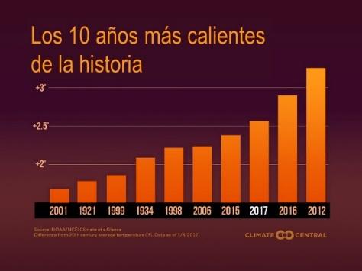 | - Explain the increased risk of heat stress through global warming.  Trainer: You may have heard people talking about global warming. This slide talks about that. Today’s temperature is 3 degrees Fahrenheit hotter than in the past. This graph shows temperatures changes from 1890 to 2020 – The temperature has been increasing over time, supports the point of environmental heat. Even though one might be working in the fields for 10 years, you are more susceptible to heat illnesses today than 10 years ago because the temperature is hotter.  Climate change has made humans more vulnerable. Everybody is at risk of heat stress, particularly those expose to high temperatures.
Slide 21  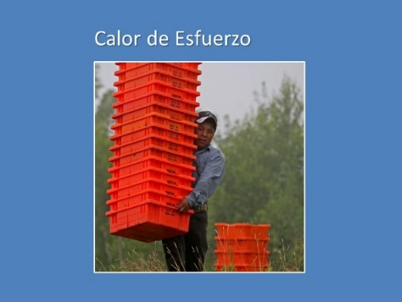 | 1) Ask participants the meaning of “exertion heat”. Allow participants to answer the question.  2) Explain “exertion heat” through examples.  - Exertion heat refers to the rise in body temperature resulting from your work.  Trainer: Just like an engine heats up while it is running – thereby requiring a radiator to cool it down – your body generates heat when it works. The harder you work, the more heat you generate. For instance, let suppose that you are running a stick shift car and you do not know how to make the changes, so you run it in first the whole time, if you speed the engine is not going to hold, is going to overheat or explode. The same happen with our body, if we are not ready or know at what speed to work we are going to overheat… we may not explode, but our body is going to experience what we see with the car.  Exertional heat means that the harder you work, the more heat you produce. Because you are running around, carrying weight, and bending over you produce more heat. Hence, it is important to stay hydrated so your body can cool down.  - Ask participants what are some ways that farmworkers create exertional heat in the fields. Wait for responses.  Trainer: The harder you work or the harder the task you are doing, for example:  - Running instead of walking  - Rapid hand or arm movements  - Frequent bending and straightening  - Overfilling buckets or containers  - All these generate exertion heat
Slides 22-24  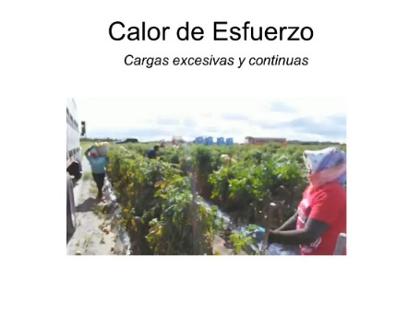  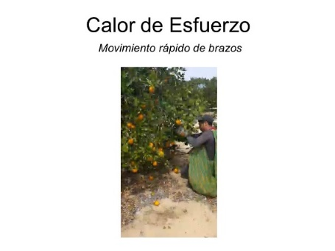  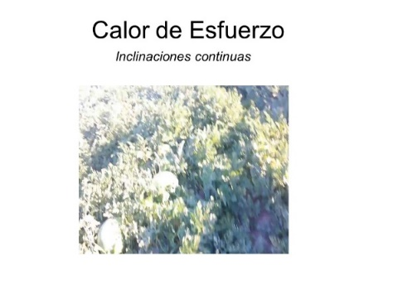 | - Show the video and state the importance of taking breaks.  Trainer: Let’s see this short video(s) and see if you can tell me who may be generating more heat.  Recent studies had shown that the piece-rate system may increase the risk for heat related illnesses because it encourages a faster pace of work. It also prevents workers from taking water breaks – which is essential to replace water lost by sweating – and rest breaks that help your body to cool down. We understand that your pay depends of how much you are making per day, but you should also be aware that if you burn out, you may be out for a while, and you will not be able to work.
Slide 25  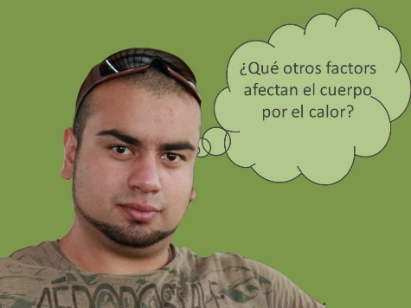 | - Ask the question on the slide. Allow participants to answer the question.
Slide 26  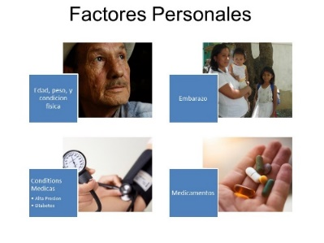 | Transition: We already covered the main idea that heat illness is caused by dehydration because farmworkers sweat so much, and that the main reason farmworkers sweat so much is because of environmental conditions and how hard farmworkers work. But there are other physical and health conditions that will increase our risk to the heat.  - Ask participants what health factors would put a person at greater risk. Wait for participants to respond.  - Discuss some factors and health conditions related to heat illness.  Trainer: These are a few factors and health conditions that can put someone at a greater risk of heat illness: age, weight, pregnancy, past health-related illness, heart conditions, diabetes, and certain medications such as…  - Allergy medicines (antihistamines)  - Cough and cold medicines  - Blood pressure and heart medicines  - Irritable bladder or bowel medicines  - Laxatives  - Mental health medicines  - Seizure medicines  - Thyroid pills  If you have these, it would be good to talk to your doctor about the work you do and ask whether or not there are any special precautions you need to take.  - Go through the four key points listed on the slide.  Trainer:  Age is an important factor because the amount of water we have in our body change overtime. When we are young we have more water, when we become older we have less water, so if we are not well hydrated we will be more at risk to HRI.  Weight is important because the fatter we are the more heat we are going to produce, on the contrary a well fit person may decrease the risk of HRI.  Pregnancy tent to elevate the temperature in the body, which may increase the risk of HRI.  Finally, many medications increase our risk because they will increase the amount of water we have.  - Ask participants how to prevent heat stress while working in the fields. Wait for participants to respond.
Slide 27  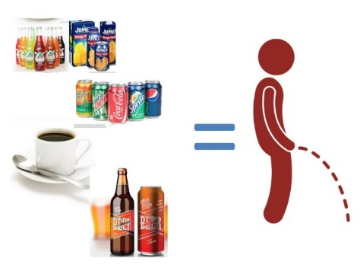 | - Ask participants if they drink coffee in the morning.  - Explain “diuretic” by using coffee as an example.  Script: Well, the caffeine in coffee is a diuretic. What does a diuretic do? … It makes you excrete water – primarily by increasing how often how much you have to pee! The more you pee the more water you lose, and the more likely you are to get dehydrated. So, if you drink coffee in the morning, drink a glass of water, before and after the coffee to replenish the water you will be losing. The other option is not to drink coffee, and drink just water.  Energy drinks make us feel stronger because they have a lot of caffeine: more than most other drinks. However, because of that caffeine, they are cause you to pee more. Again, if you drink them, drink additional water to compensate for the water you will lose; or just stop drinking them, not just for the caffeine, but because the amount of sugar they have. We will be back to sugar next, but for now:  - Ask participants if they know other common diuretics.  - Point out that alcohol is another common diuretic.  Trainer: Alcohol is another common diuretic. Think about it, what do you feel when you have a hangover?  - Thirst  - Headache  - Dizziness  - upset stomach  - Chills  All of these are caused primarily by dehydration. Think about, if drank 10 beers last night – how many times did you go to the bathroom to pee – probably at least 10 times. So alcohol always leaves you more dehydrated: never drink alcoholic beverages in an attempt to replace fluids.
Slide 28  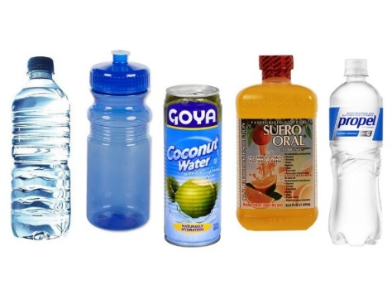 | - Explain that sugary beverages will affect how human body deal with heat (Soda, sport drinks, coconut water).  Trainer: Remember what we talk about a good circulation and sweating to control heat. Sugary beverages affect your circulation and increase your desire to go to the bathroom. It is true, water alone may not be enough for your body to stay healthy in the fields. When we sweat we are also losing electrolytes, just like we talked about it before. And you may be able to get some of those elements on sodas or even beer, but they can also affect how you deal with heat.  The so called sport drinks are a bit better than regular sodas, but they still have good amount of sugar. For example, a can of coke has 10 table spoon of sugar, coconut water have 4, and your lemonade will have as much sugar as you please, some people will do their own drink adding a bit of salt to it.  Water, like food, has a process for our body to absorb it. You do not eat and go to the bathroom then, later. The water is the same. The human body can take between 5-120 minutes to absorb all the water and carry it into the bloodstream. The great difference in absorption time is due to different factors. For example, when you have an empty stomach, the water is absorbed in just 5 minutes, but with a stoma, it will take at least 45 minutes.  Finally, I have seen much and more coconut water in stores, that's good, but look at the labels and check that they do not have extra sugar, most of them have, but there are also some that do not have extra sugar in the can.
Slide 29  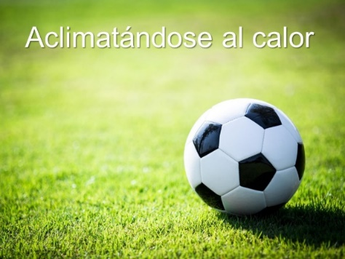 | - Ask participants if they know the meaning of “heat tolerance” or “acclimation”. Wait for participants to respond.  - Explain “heat tolerance” or “acclimation” through example.  Trainer: The basic idea is that it takes time for people to “get used” to the heat or the humidity, or it takes time for people to get used to the type of work that is done in the fields.  Did you remember when I told you the story of the Zacatepec Soccer Team? The players of that team were used to play under very hot conditions. Their body was acclimatized to the heat, while the visiting players were not. Our body, like the body of that pinging may not be used to the heat of the desert. Acclimation is the process by which you become physically adjusted to the temperature of your environment.  - Stress the following main points  - Individuals who aren’t used to heat, must be extra careful.  - No heat tolerance = higher risk for heat-stress.  - Humans get used to the heat within 4 to 14 days. But they can also lost their acclimatization as quick as in 2 days.  - Pay special attention to new and returning workers.  - Point out the following groups that need to be extra careful.  - New employees  - People just back from being sick  - Anyone absent for more than 2 weeks  - People who have just moved from a cooler climate
Slide 30  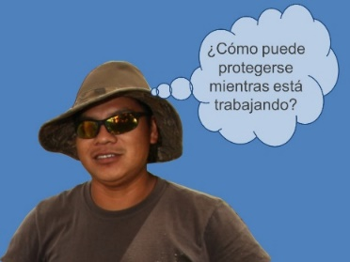 | - Ask the question on the slide. Allow participants to answer the question.
Slide 31  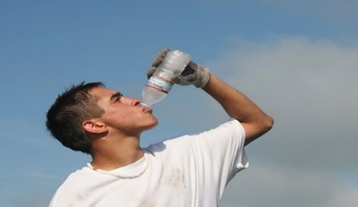 | - Stress the importance of drinking water.  Trainer: The key idea for preventing heat illnesses is to drink water. There is really no such thing as drinking too much water – so don’t hold back on drinking water.  We understand that some of you have suffered or have seen others suffer from dizziness or vomiting from drinking lots of water. It's not that the water makes them sick, it's that a lot of water without electrolytes causes the body to lose salts. Many of you do not want to drink a lot of water because they go to the bathroom, it is better to lose a little time, than to get sick from the heat. Sweating could reduce the urge to go to the bathroom.
Slide 32
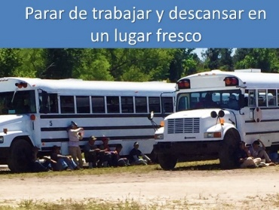
Slide 33  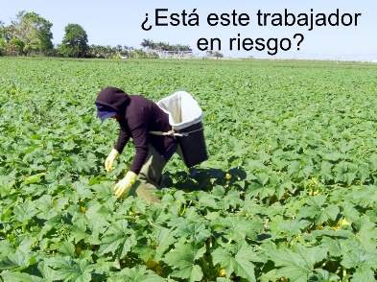 | - Point out the proper clothes that farmworkers should wear to prevent heat stress.  Trainer: Finally, farmworkers can prevent heat stress and related illnesses by being attentive to the clothes they wear while they are working  - Ask participants what they think about this worker’s clothes? Wait for participants to respond.  - Discuss the worker’s clothes.
Slide 34  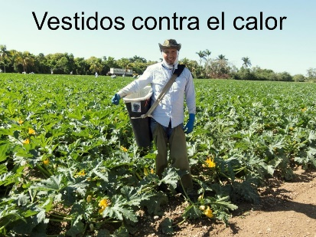 | - Discuss the worker’s clothes.  Trainer: OSHA recommends, that field workers should wear light-colored, light-weight clothing and a wide brim hat to prevent heat-stress.
Slide 35  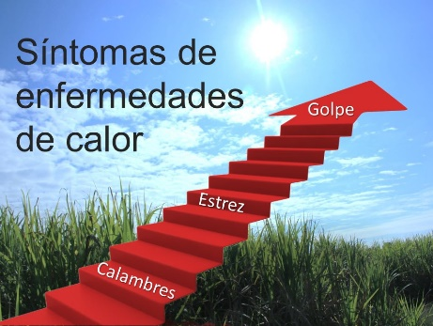 | Transition: The last thing we need to talk about today is the signs and symptoms of heat illnesses, and what to do when you spot them.  - Ask participants what the common signs and symptoms of heat stress are. Wait for participants to respond. Give positive feedback.  Trainer: As a matter of fact, these signs and symptoms can be grouped together in three main ways that we’ll talk about next.
Slide 36  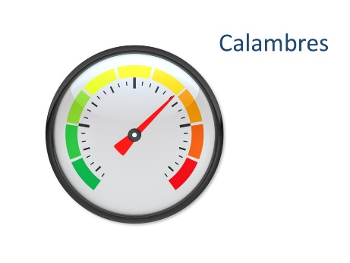 | - Show the signs and symptoms of heat stress exposure.  - Start with lower risk to higher risk
Slides 37-39
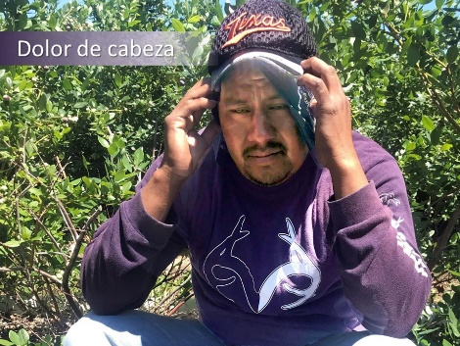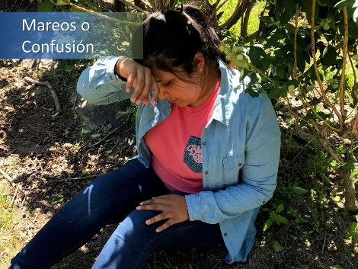
Slide 40  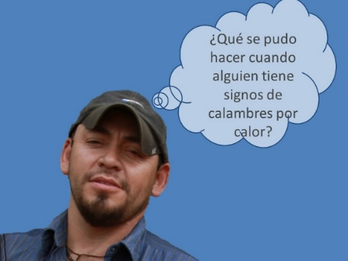 | - Ask participants what can be done when someone has signs of heat cramps. Wait for participants to respond.  Recommended answers:  - Stop all activities and rest at a cool place  - Drink water or sports drink  - Stretch and massage affected muscles  - If there is no improvement, seek immediate medical help
Slide 41
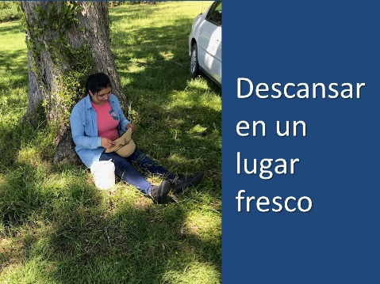

Slide 42
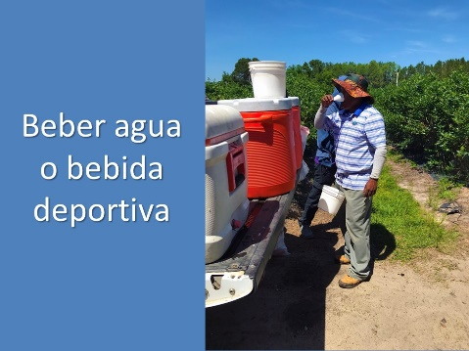
Slide 43
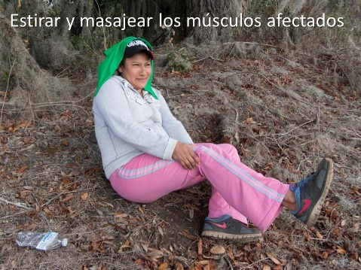
Slide 44
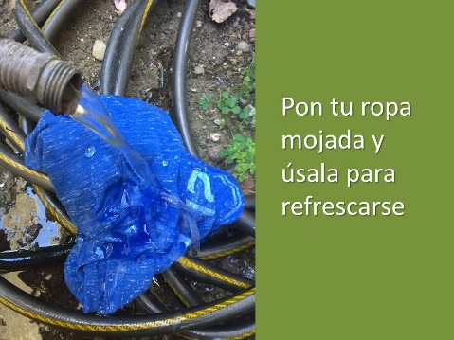
Slide 45  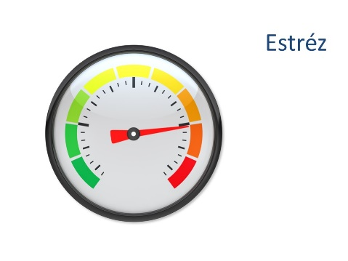 | - We are moving to more serious level of heat related illness
Slide 46  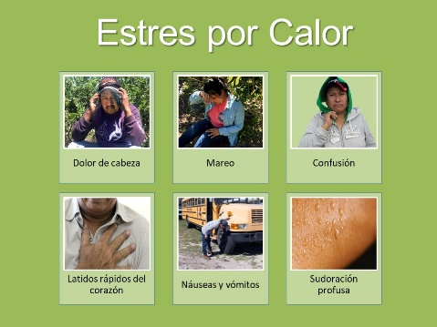 | - Explain heat exhaustion and the symptoms.  Trainer:The second stage of a heat related illness is the heat exhaustion. Our body has raised the needle to the red section of overheating, the red light is on in the car we saw at the beginning. Symptoms include:  - Headache  - Dizziness  - Confusion  - Fast heartbeat  - Nausea and vomiting  - Profuse sweating  Our body at this stage will go over our normal 37℃ up to 40℃.  Like before it may occur during or after working in the heat, and there is no order in which appear.
Slide 47
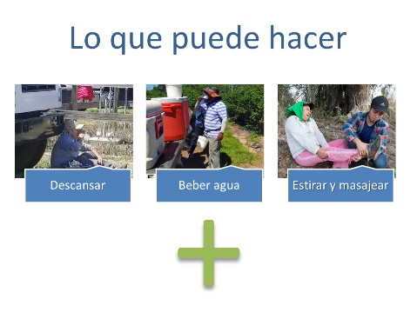
Slide 48  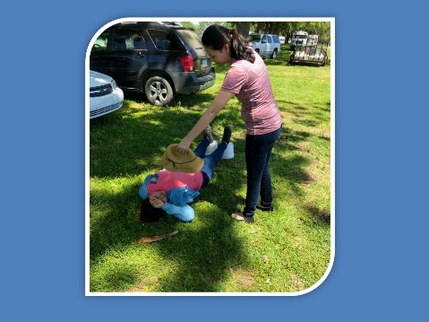 | - Present a scenario of a worker suffering from heat exhaustion and ask participants what to do.  - Explain the proper procedures of helping people with heat exhaustion.  Trainer: If you suspect that the person is suffering from heat exhaustion you should:  Immediately move the person to a cooler location, even on AC rooms. It is true, extreme and sudden changes in temperature from hot to cold can be adverse for the body. However, it is better to have dry skin and eyes, a small cold or muscular pain, than getting into levels of temperature in which you can lose your life or your brain.  - Have them rest lying down and loosen all clothing, especially around the neck, chest, and waist.  - Place wet/cool cloths on as much of the body as possible. Especially armpits and groin areas  - Sip water if alert and able to drink
Slide 49
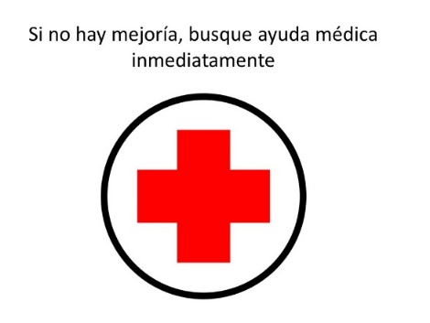
Slide 50  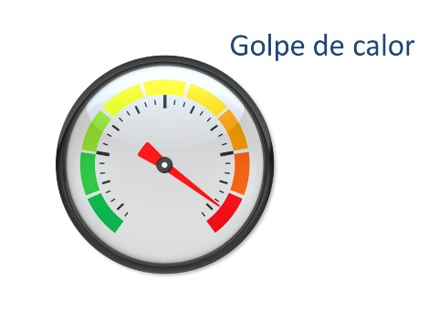 | - We are going to talk now about the more serious cases of heat related illness
Slide 51  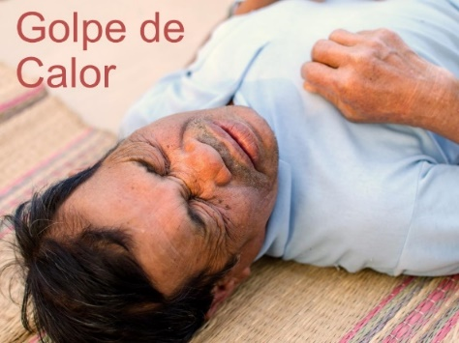 | - Explain what heat stroke is.  - Feel free to use the heat stroke example if time allows.  Trainer: We finally arrived to the riskiest of this illness: heat stroke. Remember the first video we saw. Not all the people who suffer of heat stroke die, many may survive, spend some time in the hospital, but they are now more susceptible to heat related illness. Some other suffer brain damage, because blood circulation stop getting oxygen to the brain and suffers permanent damage.  Heat stroke example: In 2017, a person in La Belle, Florida had a heat stroke as severe that now he can’t talk, walk, or know when he has to go to the bathroom; father of four children.
Slide 52  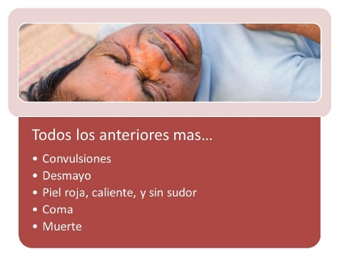 | - State the symptoms of heat stroke.  Trainer: Our body has a limit, and when we suffer a heat stroke our body’s heat-regulating system is overwhelmed by excessive heat; our body by itself is not going to cooldown. Our core temperature has got above 40o C and the symptoms include:  All the previous symptoms, remember the cascade effect, plus  - Convulsions  - Fainting  - Red, hot and dry skin.  - May result in coma or even death
Slide 53 | - Point out the immediate medical assistance – CALL 911!
Slide 54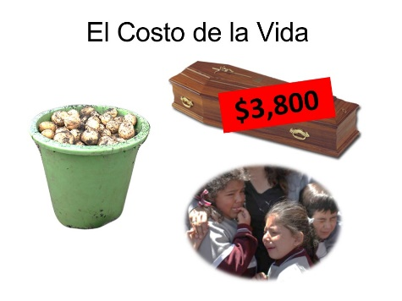 | Transition: Let’s have a reality check. We know that a lot of workers purposefully don’t drink a lot of water during the work day. We know that they don’t want to take water breaks, they don’t want to take bathroom breaks –  - Ask participants why don’t farmworkers want to drink water during the day or take breaks? Wait for participants to respond.  Script: Some of these cultural or personal beliefs may lead to the person taking risky behaviors, increasing the risk for heat-related illness.  *Notes to facilitator:  The following are beliefs that people might have.  “I’m tough, I don’t need a water break”  “I’m not thirsty~ I don’t need a drink”  “I’ll lose pay if take a water break”  “I’ll be letting my team down”  Have you heard anyone saying that?  “I’m new here~ I need to prove myself”  “The crew leader is going to get mad”  The crew leader might say:  “We’re going to take a break in a little while”  “I am going to lost weigh by sweating”  - Compare the importance of family and life to money  Script: It is important for people not to fall for these beliefs. All we ultimately want is for farmworkers to be healthy and drink water which is the most important way of staying hydrated and preventing heat-illness.  You really think that the extra cents for a buckets worth leaving your family behind. Do you know the saying?  Lento que voy de prisa, or  Más vale paso que dure y no trote que canse  We all have to provide for our families, but we want to do it in the long run, not just for a few time at the cost of our own health.
Slide 55  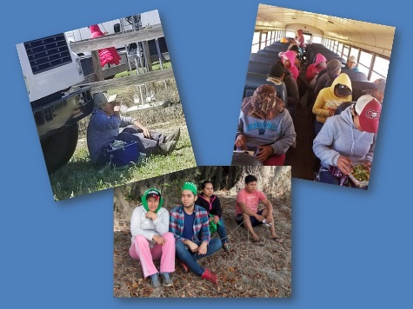 | - Summarize the key takeaways of the training. Be sure to discuss the following points.  - Anyone can be affected by heat-related illnesses. But heat-related illness are PREVENTABLE! You do not have to die by heat if you take action.  - It is agricultural workers who are most at risk of heat-related illnesses. To the point of being the occupation with the highest number of heat deaths.  - The risk of suffering a heat-related illness is because agricultural workers sweat a lot and become dehydrated. Lack of water causes heat-related illnesses.  - Our body is mostly water, and when we lose water, or we begin to dehydrate, affects all the systems of our body.  - Heat-related diseases are progressive diseases, the symptoms can be easily identified and therefore can be prevented.  - Workers who have just arrived in the region, new workers and workers with certain health conditions are at greater risk of heat-related illnesses.  - Drinking water regularly - a glass of water every hour - is the most important thing you can do to prevent heat stress.  - Avoid caffeinated and alcohol lic beverages during work because they will lose water and dehydrate.  - High fat foods and sugary drinks during the work day increase body heat and impede their ability to cool the body.  - Light colored clothing and breathing material helps cool your body.

Appendix
Florida Worker’s Compensation Law
http://statelaws.findlaw.com/florida-law/florida-workers-compensation-laws.html
Below, you’ll find a chart laying out Florida workers’ compensation laws, followed by answers to your questions about how workers’ comp works in the Sunshine State.
Statute of Limitations | - 30 days to report your injury to your employer, though there are exceptions (§ 440.185)  - 2 years is the hard deadline for filing petitions for benefits, but even then there are exceptions (§ 440.19)
Limits on Benefits | - $863/week as of 1/1/2016 (FL Rate Table)  - TTD benefits = 66 2/3% of your avg. weekly wages, 80% for critical injuries (§ 440.15(1))  - TPD benefits = 80% of the difference between 80% of your wages pre-injury and your wages post-injury (§ 440.15(4))  - Impairment benefits are determined by your impairment rating (Impairment Income Benefit Calculator)
Time Limits on Benefits | - Benefits begin on day 8 for disabilities that last less than 22 days (§ 440.12)  - If the disability lasts more than 21 days, benefits are allowed from day 1 (§ 440.12)  - Benefits for psychiatric claims stemming from physical injuries are limited to 6 months  (§ 440.093)  - 104 weeks of TTD and/or TPD benefits  (§ 440.15)
Other Limits | - Double damages for injuries suffered by illegally employed minors (§ 440.54)
What are workers' compensation benefits?
Fortunately, Florida requires most employers to provide workers' compensation insurance for their employees. In Florida, workers' compensation benefits are essentially a form of wage replacement. How much you are entitled to receive depends on how much your ability to work is impacted by the injury. In Florida, you do not need to prove that your employer was at fault for your injury—only that the injury occurred while you were working.
Most accidental injuries and occupational diseases which occur in the course and scope of employment are covered by workers' compensation. However, mental or nervous injuries are not covered unless they stem from a physical injury.
Will I receive benefits equal to my wages?
No matter how much your wages are, if you make more than $20 per week, your disability compensation will be limited to 100% of the statewide average weekly wage. As of January 1, 2016, the maximum weekly compensation was $863. The amount you may receive may be further limited based on the percentages below.
What benefits are available?
In addition to medical care coverage, three types of benefits are available: temporary total disability (TTD), temporary partial disability (TPD), and impairment benefits. TTD benefits are equal to 66 2/3% of your regular wages in most cases. If you can return to work but are unable to earn the wages you were earning prior to the injury, TPD benefits pay you 80% of the difference between 80% of your wages before your injury and what you are able to earn now. Finally, impairment benefits pay you for any permanent disability resulting from your injury.
Do I need to report my injury during a certain period of time?
While there are exceptions, generally you must report a work related injury within 30 days of the date or initial manifestation of the injury. Ultimately, you must file a petition for benefits within 2 years of your injury, but even then there are exceptions to the 2 year limitation.
When do benefits begin and for how long?
In Florida, when your benefits begin depends on how long your disability lasts. If your disability lasts fewer than 22 days, your benefits do not begin until day 8 of your disability. However, if your disability lasts more than 21 days, you may receive benefits dating back to day 1 of your disability.
Whether you are receiving TTD or TPD benefits, you can receive only up to 104 weeks of benefits. If you are receiving 80% of your regular wages due to a critical injury, the time limit is shortened to only 6 months.
Are there any restrictions I should know about?
In Florida, your workers' compensation insurance company must authorize the doctor who is treating you. Also, unlike many other states, workers' compensation laws in Florida do not require that your employer keep your job available for you to return to when you are healthy enough to do so.
What can I do if my benefits are denied?
If your benefits are denied, an attorney can help you file a lawsuit against the workers' compensation insurance company. Your claim might be based on many causes of action, including an inaccurate diagnosis by the workers' compensation insurance doctor or an inaccurate calculation of your regular wages.
Having Trouble Getting Your Benefits? Get a Free Claim Review
Florida's business-friendly laws could easily prevent you from getting the benefits you are legally entitled to. Whether you are concerned that the doctor you were instructed to see misdiagnosed you or your insurance is simply refusing to pay your benefits, speak to a Florida workers' compensation attorney for a free claim evaluation.

Georgia Worker’s Compensation Law
https://statelaws.findlaw.com/georgia-law/georgia-workers-compensation-laws.html
The chart below summarizes key aspects of Georgia's workers' compensation laws.
Statute of Limitations | - You have 30 days to give notice of your injury to your employer, with some exceptions (§ 34-9-80)  - You must make a claim for your injuries within 1 year from the date of injury or the date of the last remedial treatment OR 2 within 2 years after the date of the last payment of weekly benefits  (§ 34-9-82(a))  - 1 year from death for claims for death (§ 34-9-82(b))
Amount Limits | - TTD (§ 34-9-261):  - Benefits max = $575/wk, min = your avg. weekly wage if less than $50/wk  - 2/3 of your average weekly wage  - TPD (§ 34-9-262):  - Benefits max = $383/wk  - 2/3 of the difference between your avg. weekly wage pre-injury and your current avg. weekly wage  - Total max = $134,050.  - PPD (§ 34-9-263):  - Benefits max = $575/wk  - 2/3 of your average weekly wage  - Death Benefits (§ 34-9-265):  - Benefit max: $575/wk  - Burial benefits up to $7,500  - A widowed spouse with no children may recover a max of $230,000.  - Medical care:  - Unlimited for 400 weeks for most injuries.  - For catastrophic injuries, they are unlimited for your lifetime.
Time Limits | - Benefits begin on day 8 for disabilities that last less than 22 days (§ 34-8-197)  - If the disability lasts more than 21 days, benefits are allowed from day 1 (§ 34-8-197)  - 78 aggregate weeks of TTD while employee is capable of working with limitations (§ 34-9-104(2))  - 400 weeks of TTD for most injuries (§ 34-9-200(2))  - 350 weeks of TPD.
Other Limits | - Certain categories of workers exempt (§ 34-9-2)  - Employers may limit employees' choice of treating physician (§ 34-9-201)  - No coverage for psychiatric, psychological, heart, or vascular diseases unless they arise from a separate occupational disease (§ 34-9-280)  - Georgia does not require that your employer keep your position available for you to return to once you have recovered from your injury
What are workers' compensation benefits?
In Georgia, workers' compensation benefits are a form of wage replacement, intended to provide you with income while you are unable to work or unable to work at full capacity. You do not need to prove that your employer was at fault for your injury, but you do need to be diagnosed by a doctor who is authorized by your employer.
What kinds of injuries are covered?
Most injuries that arise out of and in the course of employment are covered, whether you or your employer is at fault for your injuries. However, psychiatric, psychological, heart, and vascular diseases are not covered, unless they arise from a separate occupational disease.
Are all employees covered by workers' compensation insurance?
No, Georgia exempts these general categories of workers:
- Employees who work for an employer who has less than 3 regular employees
- Most railroad employees
- Farm laborers
- U.S. government employees
- Domestic servants
- Independent contractors

What can I do if my claim is denied?
If you try to submit a claim for a psychiatric condition, such as post-traumatic stress disorder, your claim is likely to be denied. However, if your psychiatric, psychological, heart, or vascular disease arose from a separate occupational disease, you may be entitled to workers' compensation benefits. Your claim may also be denied if your employer claims that you are not an employee, but instead you are an independent contractor.
If your claim is denied, you may request a hearing before the State Board of Workers' Compensation. Often, you will be required to go through mediation before your hearing. Because both hearings and mediation are complex legal procedures, you may want to consult with an attorney in order to better protect your rights.
Who can help me protect my rights?
Between percentages that are tough to compute and compensation maximums, it can be challenging to navigate Georgia workers' compensation laws. To insure that you are receiving all of the benefits you are entitled to receive, speak to an experienced Georgia attorney for a free claim evaluation.

References

